**Event Report**

1. Total number of registrations : **204**
2. Total number of participants : **197**
3. No.of colleges participated : **12**
4. Top 3 winners of event - **1. Vikas Sharma (IMS Engineering College)**

**2. Aadhya Gupta (IMS Engineering College)**

**3. Gauri (IMS Engineering College)**

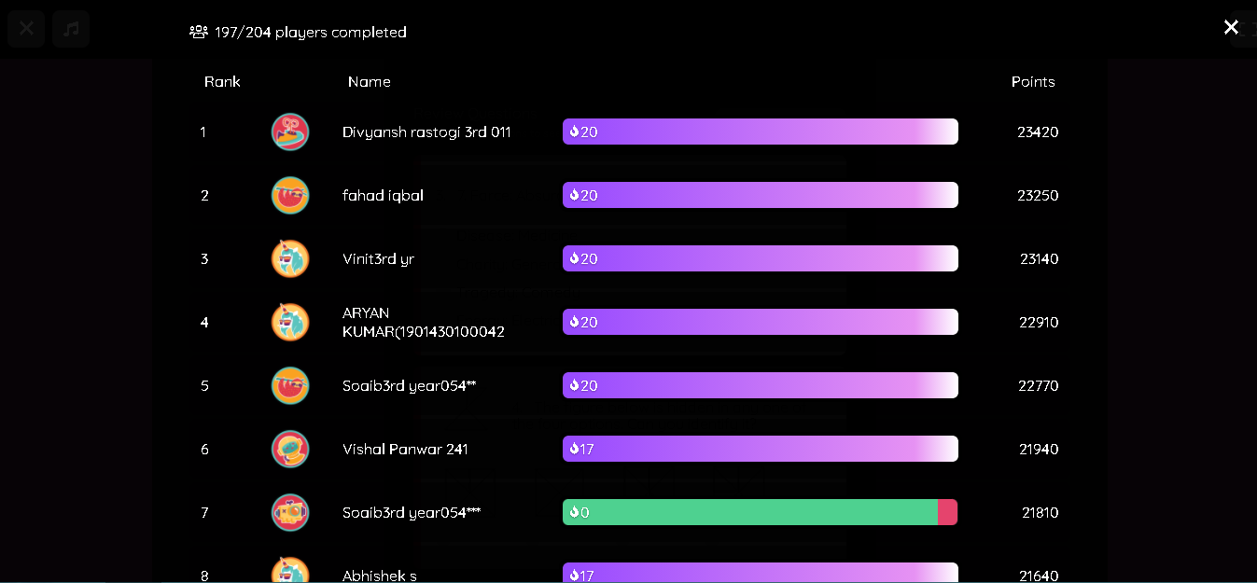

1. Social media promotions

